**ODE Analysis Using**

**Simulink**

Lab: 06



Fall 2022

CSE-3L Control Systems

Submitted by: **Amir Suliman**

Registration No: **19PWCSE1805**

Class Section: **B**

“On my honor, as a student of the University of Engineering and Technology, I have neither given nor received unauthorized assistance on this academic work.”

Student Signature: ______________

Submitted to:

**Dr: Muniba Ashfaq**

November 15, 2022

Department of Computer Systems Engineering

University of Engineering and Technology, Peshawar

**Objectives:**

* To analyze ODEs on Simulink with initial values
* To know how to use Simulink components such as gain, integrator, and multiplexer

**Task 01:**

**Equation:**

y’’ + y2 y’ – y’ + y = 0

y’(0) = 0 , y”(0) = 12

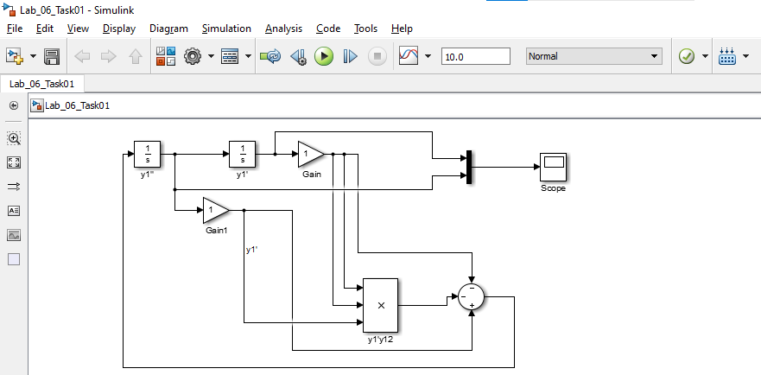

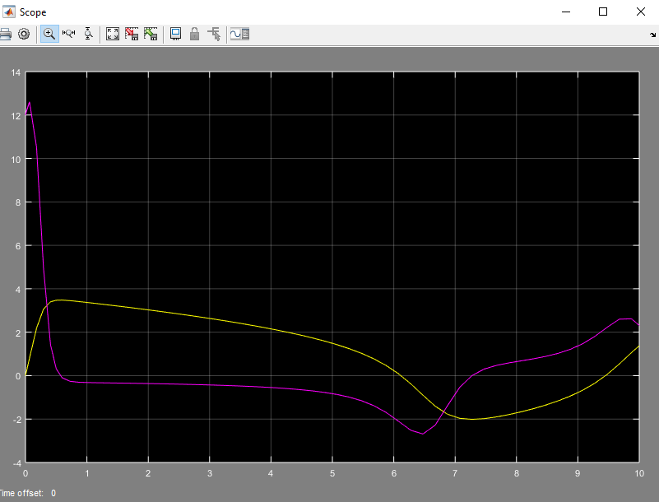

**Task 02:**

y’’”’ + 2y”’’ + 24 y’’’ + 48 y’’ + 24 y’ + 20 y + 10 = 0

y(0) = 2 , y’(0) = 5, y’’(0) = 10, y’”(0) = -4, y’’”(0) = -7

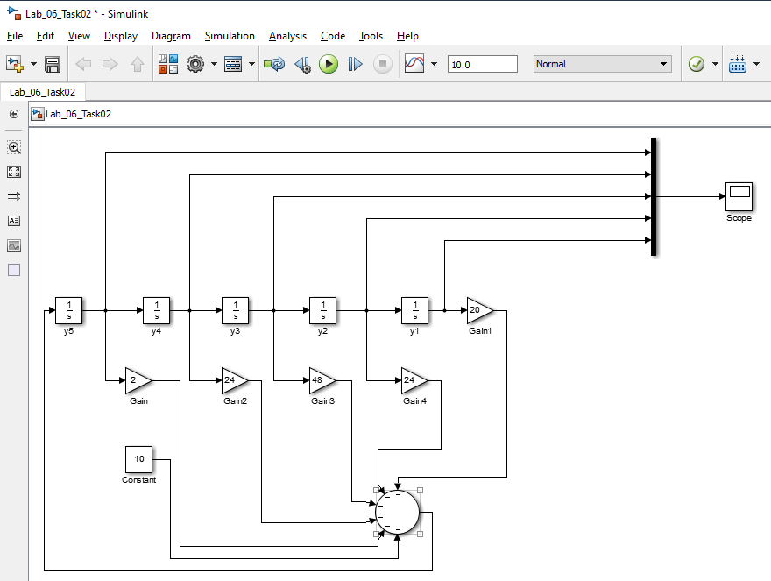

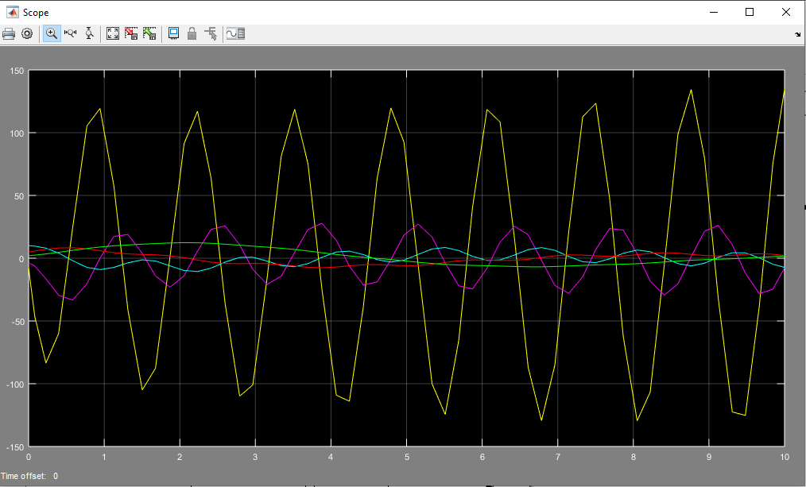

**Task 03:**

-16 y’’’ + 8 y’’ - y’ - 6 y + 20 = 0

y(0) = 4, y’(0) = 0, y’’(0) = -6, y’”(0) = 2

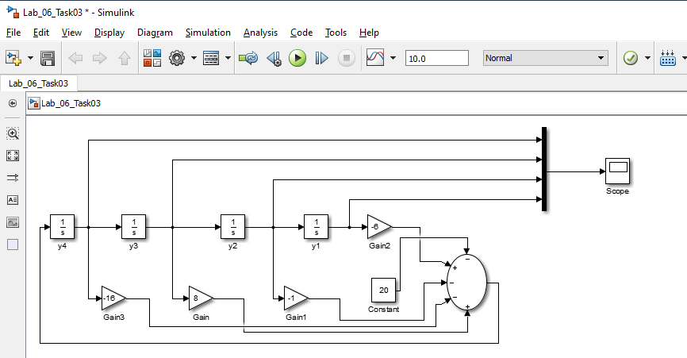

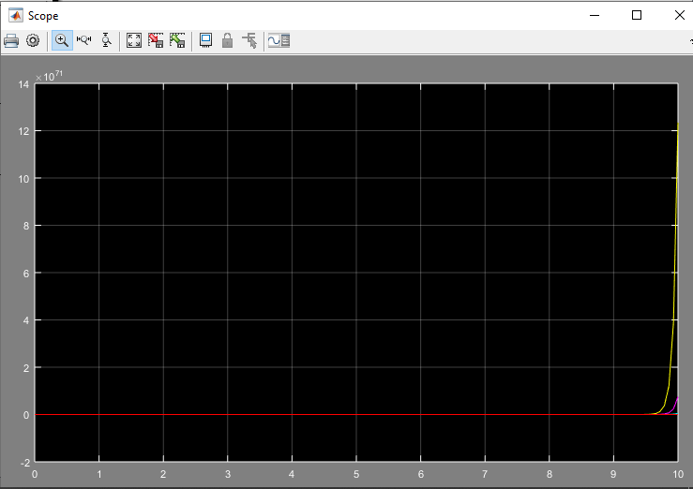

End